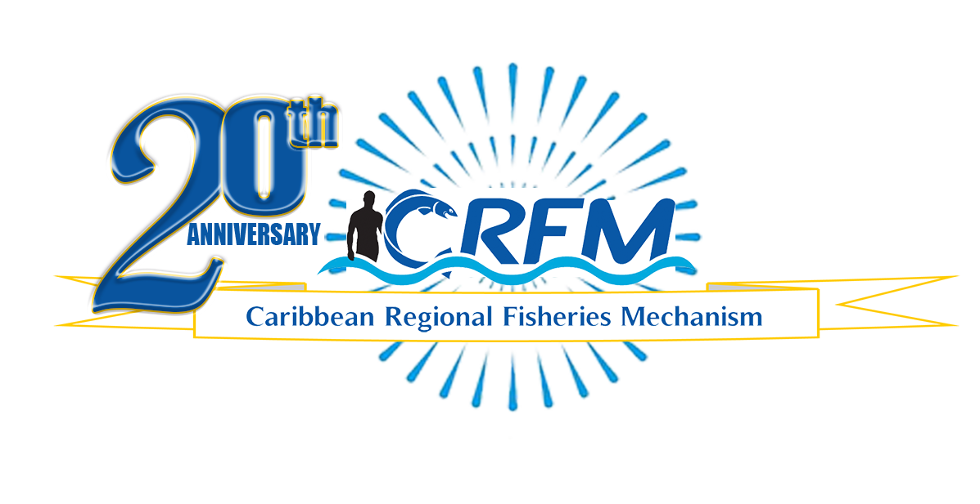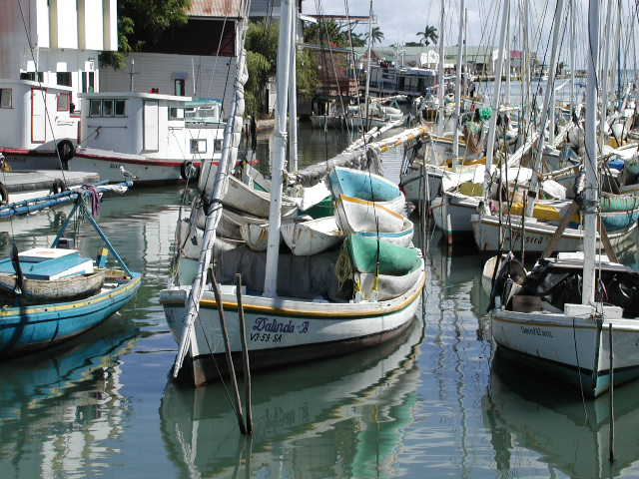

PRESS RELEASE

PR#001-2024

*Towards Sustainable Development of*

*Fisheries for the People of the Caribbean!*

Caribbean Fisheries Forum concludes deliberations

on fisheries and aquaculture

Belize City, Friday, 8 March 2024 (CRFM)—Several Member States of the Caribbean Regional Fisheries Mechanism ([CRFM](https://crfm.int/)), as well as representatives of regional and international observer organizations, including the Caribbean Network of Fisherfolk Organisations (CNFO) and the Food and Agriculture Organization of the United Nations (FAO), met from Wednesday, 6 March to Friday, 8 March 2024, to deliberate on developments in fisheries and aquaculture. The CRFM convened this 22nd Regular Meeting of the Caribbean Fisheries Forum to receive technical inputs from national fisheries authorities across the Caribbean, as well as key stakeholders and partners, in addressing the priorities of the sector.

The Forum also held elections for a new chair and vice chair, as well as members of the Executive Committee of the Forum and the Resource Mobilization Sub-committee. Trinidad and Tobago, which served as chair of the Forum for the past year, handed over the leadership to the Turks and Caicos Islands. After the elections, Kathy Lockhart, Assistant Director of Fisheries, Department of Fisheries and Marine Resources Management, Turks and Caicos Islands, assumed the Chair, succeeding Louanna Martin, Acting Director of Fisheries, Fisheries Division, Trinidad and Tobago.

In welcoming attendees to the Forum Meeting, Martin highlighted the value of the CRFM, an intergovernmental institution of the Caribbean Community (CARICOM), to Trinidad and Tobago, one of its 17 Member States. She said that the CRFM has been very instrumental in helping to address the myriad issues that confront the fisheries and aquaculture sector.

During the opening session, Milton Haughton, Executive Director at the CRFM Secretariat, noted that the Caribbean Fisheries Forum was meeting against the backdrop of myriad challenges as well as opportunities for harnessing the benefits of blue economic growth.

“Notwithstanding the various global crises—the wars in Ukraine and the Middle East—and the challenging economic situation in many of our countries, we have to continue to work hard to strengthen our economies and to provide new opportunities for growth, especially for the youth, which is very important for our future prosperity,” Haughton said.

He added that this prosperous future lies in utilizing the Caribbean’s aquatic resources and in developing the aquaculture potential—both on land and in the marine environment.

Haughton noted that although the CRFM has made significant strides in working with Caribbean countries over the past 21 years, there is still much more work to be done. He informed the Caribbean Fisheries Forum that the Government of Canada had recently approved CD$4.2 million in funding for the CRFM, for the Sustainable Technologies for Adaptation and Resilience in Fisheries (STAR-Fish) Project, which aims to advance the clean energy transition in the Caribbean fisheries and aquaculture sectors. He also highlighted the recent commencement of a US$48 million project being part-financed by the Global Environment Facility (GEF) titled, Promoting National Blue Economy Priorities Through Marine Spatial Planning in the Caribbean Large Marine Ecosystem Plus ("BE-CLME+”), which aims to promote blue economy development through marine spatial planning and marine protected areas, an ecosystem approach to fisheries, and sustainable seafood value chains.

The Executive Director of the CRFM briefed the Forum on ongoing initiatives, such as the Strengthening Sustainable Use and Management of Coastal Fisheries Resources in CARICOM Countries (COASTFISH) Project, being implemented with funding from the Government of Japan, and the Sargassum Products for Climate Resilience Project, being funded by the Government of New Zealand.

He also updated the Forum on the work being done in partnership with the Caribbean Agricultural Research and Development Institute (CARDI) and the University of the West Indies (UWI), to commence pilot scale production of a liquid fertilizer from Sargassum, as well as plans to ensure total and safe utilization of the resource by converting the by-products to other sustainable products.

Haughton also updated the Forum on the World Trade Organization (WTO) subsidies negotiations held last week, in Abu Dhabi, and he advised the Forum that the agreement was not finalized because significant differences remained among the countries. He advised the Member States of the critical need to pay keen attention to such international processes and to ensure that the Caribbean’s interests are defended and fully addressed, given the potential implications for the fisheries of Caribbean countries and the region.

The Forum’s deliberations, which are vital for forging the way forward for the sustainable development of the Caribbean’s aquatic resources, precede the upcoming 18th Regular Meeting of the CRFM Ministerial Council, comprised of Ministers responsible for fisheries from its 17 Caribbean Member States.

**ABOUT THE CRFM:**

The [Caribbean Regional Fisheries Mechanism](https://www.crfm.int/) (CRFM) was officially inaugurated on 27 March 2003 in Belize City, Belize, where it is headquartered, following the signing of the Agreement Establishing the CRFM on 4 February 2002. It is an inter-governmental organization whose mission is to promote and facilitate the responsible utilization of the region's fisheries and other aquatic resources for the economic and social benefits of the current and future population of the region.

**PRESS CONTACT NAME:** Milton Haughton, Executive Director **PHONE:** 501-223-4443

**E-mail:** milton.haughton@crfm.int

—Ends—