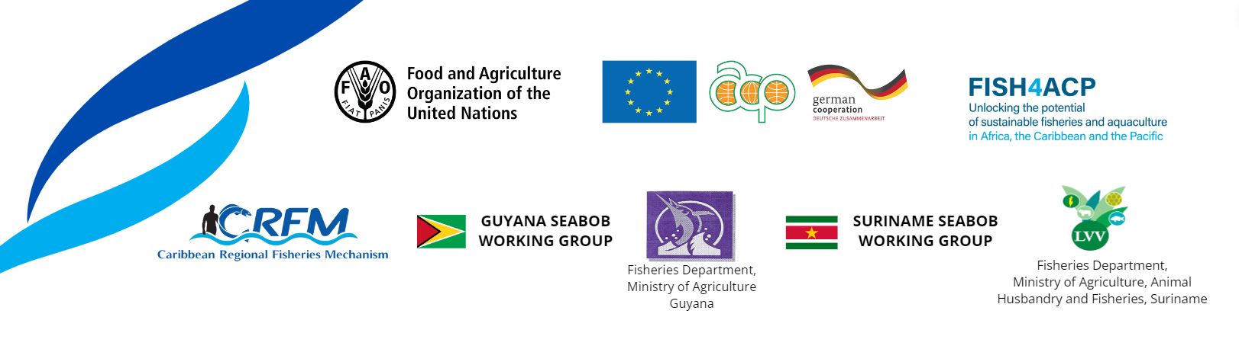

CRFM Continental Shelf Fisheries Working Group and FISH4ACP collaborate on Atlantic seabob shrimp assessment

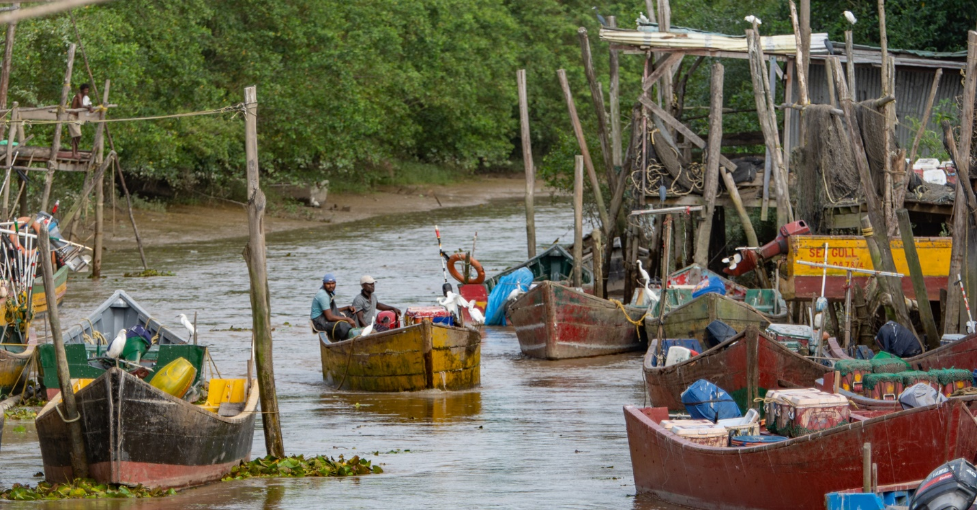
The fisheries sector in Guyana provides sustainable jobs for thousands of artisanal fishers.

Photo: FISH4ACP, Guyana

GUYANA, Tuesday, 12 March 2024 (CRFM)—A technical working group of the Caribbean Regional Fisheries Mechanism (CRFM)—the Continental Shelf Fisheries Working Group (CSWG)—is collaborating with the global value chain development programme – FISH4ACP, private sector processors, and the Seabob Working Groups of Guyana and Suriname to convene a joint stock assessment workshop in Guyana from 11-15 March 2024.

The assessment of the seabob, a short-lived shallow water shrimp found in the Western Central Atlantic, will cover the stocks of Guyana and Suriname, situated in the North Brazilian Shelf Large Marine Ecosystem. The assessment aims to review and validate the most recent scientific evaluations of the Atlantic seabob fisheries of Suriname and Guyana. The results will be shared with industrial and artisanal fishery stakeholders from Guyana and Suriname for their input during the last two days of the workshop, on 14-15 March 2024.

During the workshop, regional and international technical experts will propose harvest control rules (HCRs) and the related fisheries management plans, taking into account compliance with Marine Stewardship Council (MSC) certification requirements. The seabob fisheries in both Guyana and Suriname are MSC certified; Suriname’s fishery was first certified in 2011 and Guyana’s fishery in 2019.

The Seabob Working Groups of Guyana and Suriname—which are made up of representatives from the respective Fisheries Departments, the industrial and artisanal seabob sectors, and the World Wildlife Fund (WWF)—will subsequently lead the implementation of the outcomes and recommendations from the meeting.

The CRFM CSWG aims to promote the sustainable utilization of continental shelf resources and associated ecosystems through the review and analysis of fisheries and related data, to inform management strategies, consistent with the ecosystem, precautionary and participatory approaches to fisheries management.

FISH4ACP is a five-year fish value chain development programme, spanning 2020 to 2025. It is being implemented by the Food and Agriculture Organization of the United Nations (FAO) with funding from the European Union and the German Federal Ministry for Economic Cooperation and Development.

In Guyana, FISH4ACP is working towards a sustainable, resilient, well-managed, and inclusive shrimp fishery to strengthen the country’s position as a leading exporter of Atlantic seabob shrimp while ensuring long-term stability of stocks and bringing more benefits to local fisherfolk, especially women.

The CRFM collaborates with FAO on the implementation of FISH4ACP.

- ENDS -

