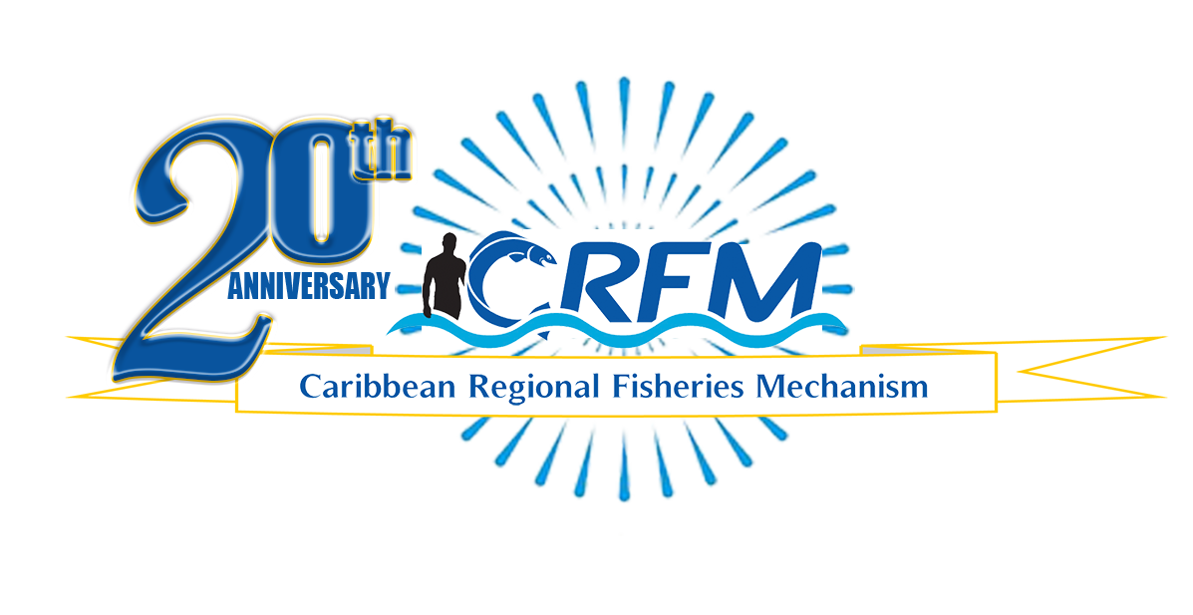
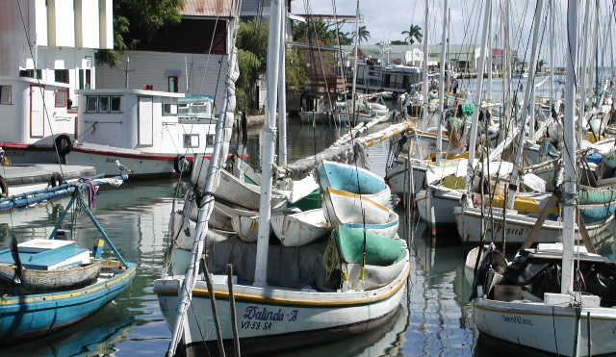

PRESS RELEASE

PR#006-2023
Towards Sustainable Development of
Fisheries for the People of the Caribbean!

CRFM Ministerial Council holds 17th Meeting
Ministers map out sustainable solutions to challenges such as fisheries management, climate change, capacity building, imbalances in international trade, and Sargassum influxes
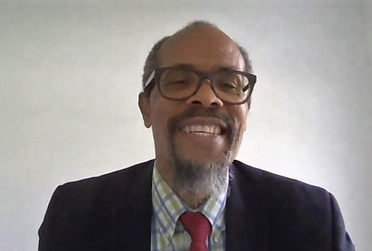
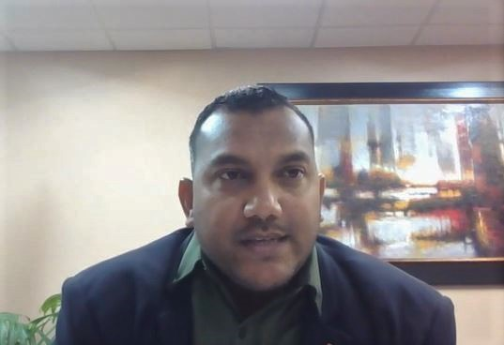
Photo: CRFM
Photo: CRFM
Mr. Milton Haughton, Executive Director, Caribbean Regional Fisheries Mechanism
Minister Avinash Singh, Trinidad and Tobago,
Chair of the CRFM Ministerial Council Meeting

Belize City, Friday, 28 April 2023 (CRFM)—The Ministerial Council of the Caribbean Regional Fisheries Mechanism (CRFM), comprised of Ministers responsible for fisheries from across the Caribbean Community, met on Thursday, 27 April 2023, to chart the way forward for the revitalization and expansion of the region’s fisheries and aquaculture sector—a goal which lies at the heart of the CRFM’s observance of its 20th Anniversary this year. During Thursday’s deliberations, the Ministers approved 32 resolutions, as they reviewed progress and mapped out sustainable solutions to challenges such as fisheries management; illegal, unreported and unregulated fishing and fisheries crime; climate change and ocean acidification; imbalances in international trade; and Sargassum influxes which are expected to reach record levels this year. Furthermore, the Ministers provided guidance and policy direction to the CRFM Secretariat and Member States on harnessing the opportunities arising in the emerging Blue Economy, through initiatives such as a new multimillion-dollar regional project to promote blue economic growth.

Hon. Avinash Singh, Minister in the Ministry of Agriculture, Land and Fisheries, Trinidad and Tobago, chaired the Seventeenth Meeting of the CRFM Ministerial Council. Trinidad and Tobago took over the reins of the Council from Hon. Parmanand Sewdien, Suriname’s Minister of Agriculture, Fisheries and Animal Husbandry, for a one-year term.

Hon. Singh acknowledged the contributions of the CRFM Secretariat in providing technical support to the Ministers during the proceedings, and for making impactful representations for Member States that benefit the entire region. He added that he looked forward to a very productive term ahead, as the CRFM continues to navigate the waters, in providing a sustainable future for the younger generations to follow.

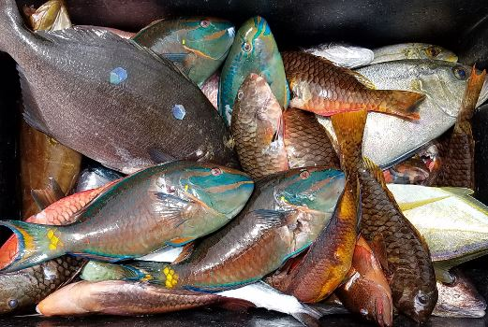
At their meeting on Thursday, the Ministers adopted the Protocol to the Caribbean Community Common Fisheries Policy on Aquatic Foods as a Strategic Resource for Food and Nutrition Security—the third protocol adopted under the regional fisheries policy. The protocol’s objective is to recognize, promote, and support the sustainable use of fish, shellfish, marine plants and seafood as a strategic resource for food and nutrition security for the peoples of the Caribbean.

Although fish production in our region is expanding, the Caribbean is still a major importer of fish and seafood. However, CRFM’s Executive Director, Mr. Milton Haughton, noted that there are projects and initiatives being implemented that should improve availability and access to safe and affordable fish and seafood to the people of the region. He announced that a US$48 million project—the CAF/FAO/CRFM/GEF/Caribbean Blue Economy Project entitled, Promoting National Blue Economy Priorities Through Marine Spatial Planning in the Caribbean Large Marine Ecosystem Plus or the BE-CLME+ Project—should commence around July 2023. The Fisheries Ministers welcomed the final approval of the Project Document by the Global Environment Fund (GEF) in November 2022, paving the way for the disbursement of funds and commencement of the project. The funding includes a US$25 million line of credit co-financed by the Development Bank of Latin America (CAF) for fisheries enterprises in the private sector to upgrade their capacities and develop fisheries value chains.
Photo: CRFM
CARICOM countries depend on fishing for food, social welfare, employment, and much more

The Ministers also welcomed the updates on the efforts by the Caribbean Regional Fisheries Mechanism and the New Zealand Plant and Food Research (PFR), under the project entitled, Sargassum Products for Climate Resilience in the Caribbean. With support from New Zealand, technical experts in agronomy, technology, engineering and business development, the CRFM and PFR are pursuing the production of liquid fertilizers, compost, and other potential products, while ensuring that any health risks associated with doing so are eliminated through the processing of the Sargassum. Haughton noted that there is a great need for affordable fertilizers for agriculture, much of which is imported. The University of the West Indies and Caribbean Agricultural Research and Development Institute (CARDI) are key partners in this initiative. The intention is to develop processes, technologies, products, and business models that can be made available to potential entrepreneurs from the region, thereby creating jobs and economic activities while mitigating the negative environmental, health and socio-economic impacts of the Sargassum seaweed.
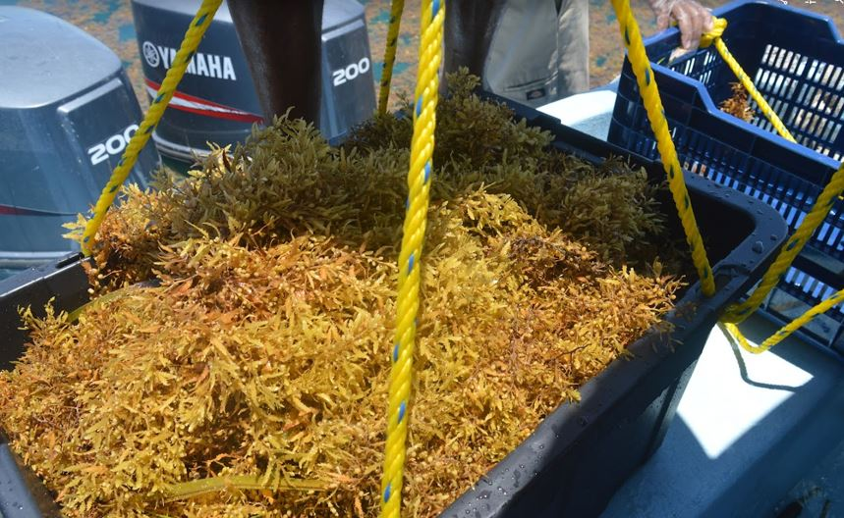
The Ministers issued a strong resolution establishing a roadmap to strengthen measures to prevent “ghost fishing” or abandoned, lost and otherwise discarded fishing gear (ALDFG), which is one of the most harmful forms of marine debris. Since 2018, the CRFM and the Global Ghost Gear Initiative (GGGI) have collaborated on prevention, mitigation, remediation, predictive modeling and capacity sharing work in the Caribbean. The CRFM Secretariat will now execute a Memorandum of Understanding with the GGGI for enhanced cooperation and coordination in addressing ghost fishing in the region.
Photo: CRFM
Sargassum sampling for testing off the coast of Belize in 2021, during phase 1 of the project

The Ministers commended the CRFM Secretariat and international development partners for the significant work done and outputs achieved during the past programme year. This body of work included various policies developed and adopted, projects advanced, technical publications completed, training and capacity building support provided, and advances in combating illegal, unreported and unregulated fishing and fisheries crime, improving sanitary and phytosanitary systems, strengthening data and information systems, as well as significant contributions to international processes.

This included the World Trade Organization (WTO) Agreement on Fisheries Subsidies, which was adopted on 17 June 2022, after 21 years of talks. The Ministers urged Member States to take the necessary actions to accept and implement the agreement as soon as possible. However, they are asking Member States to consult all key stakeholders to ensure that all relevant issues are taken into account and that the full implications of the agreement are understood prior to accepting and enshrining it into national law or policies. They furthermore urged Member States to continue working with the CARICOM and CRFM Secretariats in the process of acceptance and implementation of the agreement, and also the future negotiations to address the remaining issues and gaps that could not have been addressed when the current agreement was concluded in 2022.

The Ministers also took note of the recent conclusion of international negotiations that resulted in the formulation of the UN Agreement on Biodiversity in Areas Beyond National Jurisdiction in March 2023, and they urged Member States to take advantage of the opportunities to obtain tangible, sustainable benefits from the biodiversity in the marine areas beyond national jurisdiction.

The Fisheries Ministers welcomed the development of the Regional Strategic Framework for Cooperation between the International Atomic Energy Agency (IAEA) and CARICOM Member States (2020-2026). The Ministers are asking the CRFM Secretariat to work with the IAEA, which has the largest marine lab in the world, located in Monaco, and other regional partners to facilitate and coordinate cooperation activities in fisheries management, aquaculture development, marine biodiversity conservation, ocean acidification, combatting illegal, unreported, and unregulated fishing and seafood fraud, and other relevant areas where the expertise of IAEA can add value.

The policymakers also endorsed the Convention on Biological Diversity Global Biodiversity Framework , which was adopted by the 15th Conference of Parties to the Convention in December 2022. The Convention on Biological Biodiversity is a global treaty adopted at the United Nations Conference on Environment and Development in 1992. The framework sets out the global biodiversity agenda for the next decade, with the overarching goal of living in harmony with nature by 2050—a vision which the CARICOM Fisheries Ministers also endorsed.

The Council reviewed the status of a request made to FAO and reaffirmed the priority accorded to that request, for securing the services of the modern Norwegian marine survey vessel, the Dr. Fridtjof Nansen, to conduct a comprehensive survey of the marine resources in the offshore waters of CARICOM States, to support blue economic development and sustainable use of the living marine resources.

The Council is due to meet again in special session in October 2023.

– ENDS –
ABOUT THE CRFM:

The Caribbean Regional Fisheries Mechanism (CRFM) was officially inaugurated on 27 March 2003 in Belize City, Belize, where it is headquartered, following the signing of the Agreement Establishing the CRFM on 4 February 2002. It is an inter-governmental organization whose mission is to promote and facilitate the responsible utilization of the region's fisheries and other aquatic resources for the economic and social benefits of the current and future population of the region.
PRESS CONTACT NAME: Milton Haughton, Executive Director PHONE: 501-223-4443
E-mail: milton.haughton@crfm.int

